InsideBU
Spring 2015

[Heading One] Contents Page

Page 2: #ourBUstory advert

Page 3: Contents and Message from John Vinney

Pages 4 – 5: News in brief

Pages 6 – 7: 100 Years of Learning

Pages 8 – 9: Scupture for Healthcare: Interaction and Virtual Art in 3d

Pages 10 – 11: Research round-up

Page 12: By Day By Night: Gary Cowen

Page 13: A megaphone or smartphone? – May’s general election

Page 14: Public engagement in the region

Page 15: We Meet…Zulfiqar Khan and Bruce Wen

Pages 16 – 17: #BU Proud Gallery/Twitter feed

Page 18: Dates for your diary

Page 19: Festival of Learning advert

Page 20: AFCB Advert

[Heading Two] Message from John Vinney

Welcome to the latest edition of InsideBU – the magazine that keeps BU’s community of students and staff up to date with what’s going on around the university.

2015 is already shaping up to be another exciting year for BU, with the fantastic REF (Research Excellence Framework) results giving us a real sense of pride in our research. You can find out how we performed and the impact our research has on the wider community and beyond on pages 10 and 11.

Historically BU has always played an active role in the local area, engaging the public in new and innovative ways. But you may be surprised to learn that you can trace our history back over 100 years. Learn how we’ve developed as a university on pages 6 and 7, and some of the ways we continue to make a difference on page 14.

I hope you enjoy the new look and feel to this issue of InsideBU – with so much going on around the university I continue to encourage you to share your stories and successes at insidebu@bournemouth.ac.uk.

[Heading Three] News in Brief

[Sub-heading] Service Excellence Conference – Wednesday 22 April
LV will be supporting the Service Excellence Conference - now a key date in the BU calendar. The event, which takes place on Talbot Campus, gives staff from all areas of BU a chance to network, share best practice and hear from other organisations. Sign up via the Staff Intranet.

[Sub-heading] Deputy PM Visits BU
Deputy Prime Minister Nick Clegg visited BU on the day new government funding was announced to create a join business incubation centre for BU and Arts University Bournemouth.

The funding is part of an expansion of the Growth Deal for Dorset, which will see an extra £12.6 million invested in the county between 2016 and 2021.
Mr Clegg said: “I’m very impressed to see the universities work so closely together and particularly all the investment they’re making in these new buildings. Also their determination to provide support to students and graduates who want to create new businesses – not only to study here but then work here and create jobs here.”

[Sub-heading] SURE Conference – 4 March 2015 (Showcasing Undergraduate research excellence)
Research is an important part of undergraduate study, including coursework, placements, volunteering, dissertations and more.

The SURE Conference is the first event of its kind to be run by BU. It aims to celebrate undergraduate research by offering an opportunity for students to showcase their work to the wider academic community and external organisations.

Visit www.surebu.org.uk for more information.

[Sub-heading] Festival of Learning 2015
From wheelchair basketball to eating bugs, archeological digs to theatrical plays, last year’s Festival of Learning offered a diverse and exciting mix of events and activities. BU will open its doors again to the public, students and staff for the Festival from Saturday 11 to Friday 17 July.

Register for updates at www.bournemouth.ac.uk/fol.

[Sub-heading] National Student Survey (NSS)
NeSSa the Camel is back, asking final-year students to complete the NSS.
The NSS is an independent annual survey that gives final-year students the opportunity to give feedback about their institution and course.

The results are made publicly available to prospective students, their families and advisors to help make informed choices about where and what to study.
Running until the end of April, students who complete the survey will get a £5 Amazon voucher and be entered into a prize draw to win cash, VIP Graduation packages and SUBU Summer Ball tickets. Fill out the survey at www.thestudentsurvey.com.

[Sub-heading] Talk BU LIVE
Talk BU Live events are designed to get people talking, thinking and shouting! They take place once a month in Dylan’s Bar with BU staff delivering fascinating talks and sharing ideas, opinions and theories.

Previous speakers have included Professor Stephen Heppell on how we can learn better and Dr Don Parker on how advertisers invented Christmas.

Visit www.bournemouth.ac.uk/talk-bu or tweet with #TalkBU to join the conversation.

[Sub-heading] Visual effects success continues for BU graduates

A number of BU graduates are celebrating their works’ inclusion in the coveted Oscar nominations list.

They worked on the special effects for films Interstellar, Guardians of the Galaxy, X-Men: Days of Future Past and Dawn of the Planet of the Apes, which were nominated in the in the visual effects category alongside Captain America.

It’s not just the Oscars that are cause for celebration. Visual effects produced by creative BU alumni have also contributed to the success of BAFTA nominated films Paddington and The Lego Movie.

BU has a long history of producing graduates who go on to work on Oscar winning films, such as Avatar and Gravity.

[Heading Four] SUBU President, Chloe’s Column
Giving back to the community

Last year over 700 of our students volunteered nearly 4,000 hours of their time in the local community.

In 2014, students collected over four tonnes of food for local foodbanks and picked up 8,800 pieces of litter from the beach.

The chance for students to donate such a large amount of time is made easier due to the fantastic range of opportunities that SUBU Volunteering has to offer - from ‘Five-minute’ volunteering events on campus each week, to one off ‘MAD Days’ in different areas – students can get involved as and when they like, no matter how much time they have to give.

Volunteering helps students to make friends, develop key skills and enhance their CVs. Their desire to help others – and the relationships that they are building with the local community are really something to be proud of.

Visit subu.org.uk for more information.

[Heading Five] From little acorns…

In a year that will see two major new university buildings opening on both campuses, InsideBU takes a look at the historical development of BU within our region.

June 1885 - In the late Victorian decades a need for technical training was identified as vital for the growth of the local economy – the School of Science and Art was built as a result.

July 1889 – The Bournemouth West School of Science and Art opened on Poole Hill.

July 1891 - Bournemouth East School of Science and Art opened on Drummond Road and was originally run as a mechanics institute.

July 1897 - Pokesdown Art and Technical School Opened

July 1903 - The Education Committee opens a School of Commerce on Avenue Road

May 1908 - Science College for Medical and Dental student opened.
May 1910- Plans were approved for the creation of a new Bournemouth Municipal College with an approved loan of £22,955 - £2.1 million in today’s money.

May 1913 - The Bournemouth Municipal College is opened by the President of the Board of Education.

January 1924 - By this time, the College was advertising its school of literature, science, art and commerce.

January 1939 - The Municipal College of Technology and Commerce was providing full time courses.

October 1960 - In the early 1960s the college put in a bid to become one of a new group of universities, but the bid was unsuccessful.

October 1973 – Bournemouth College of Technology moved to Poole.

June 1974 - Following the merger of the Municipal College with the Weymouth College of Education, the Dorset Institute of Higher Education was formed.

January 1976 - The Research Register for the Dorset Institute of Higher Education revealed the emergence of a body of research for the institution.

September 1989 - The late 80s saw a very intensive period of course development with many unique and innovative courses developed.

July 1990 - The Dorset Institute was re-formed as Bournemouth Polytechnic.

November 1992 – Bournemouth University was inaugurated on 27 November 1992.

January 2009 – December 2010 BU is named the UK’s Number One New University according to the 2009 & 2010 editions of The Guardian University Guide.
2015 - The new Student Centre on Talbot Campus and Bournemouth University International College on Lansdowne will both open as part of a £200 million investment in the long term development of the university.

[Box out] Today we have established industry links all over the world, are recognised for our world leading research, and are proud to be the first British university to be commended for the quality of student learning opportunities by the Quality Assurance Agency.

[Heading Six] A world of Imagination

Software developed by BU academics has given children with physical disabilities a unique chance to express themselves artistically – InsideBU finds out more.

In 2010 Alexander Pasko and a team of academics from the National Centre for Computer Animation met with Victoria Education Centre - a school for children with physical and learning disabilities - about developing a software system to enable students to bring art to life.

“These children have wonderful imaginations, but almost no tools to express themselves. Giving them the tools for creativity was the primary goal for the project” explains Alexander.

Mark Moseley, an assistive technologist at Victoria Centre, was keen to take part as he had seen how the children found it hard to do art in the conventional sense: “I thought this would be a good opportunity to develop a piece of software to allow the students to have these artistic experiences, by using technology that’s able to compensate for whatever it is that they’re not able to do.”

Alexander worked alongside a team of people, including Dr Leigh McLoughlin Oleg Fryazinov, Mathieu Sanchez, Valery Adzhiev and Peter Comninos to create the SHIVA project – Sculpture for Healthcare: Interaction and Virtual Art in 3D. This pioneering technology allows students to design complex objects using only their eyes and brings them to life on a 3D printer.
“The way most of us interact is through using a keyboard or mouse” says Leigh, a lecturer in the Faculty of Science & Technology. He faced several challenges whilst writing the user interface for the software: “The children we were designing the software for had different levels of dexterity and control, so the user interface system had to cope with lots of requirements.”

The solution was a new interface that can be used with eye-tracking hardware so the user can select options just by focusing their eyes on it; they build a model by selecting a number of pre-defined objects which can be modified and rotated to create complex shapes. The final model is then produced using a 3D printer, giving the student a tangible model of their creativity.

For the SHIVA project, the team focused on those children who could use touch screens and eye gaze units, as well as those with visual impairments.

Once the software had been written and designed by the team, extensive testing was carried out to make sure it was working to the best of its ability. “With complex technology there will always be bugs, but if a child who has a disability fails to do something, they blame themselves – not the software,” says Alexander.

Leigh was delighted when he saw the children using the software: “It’s hugely significant for the children to be able to complete something entirely on their own – it builds their confidence, boosts their selfesteem and allows them to have fun.”

Alexander agrees: “When we started, it was just another project, but somewhere in the middle we realised it had become so much more.

“Seeing the children playing with and enjoying the software was wonderful – watching them laughing was such a wonderful experience.”

[Box Out] To find out more about the project, please visit www.appliedshapes.com/research/shiva.

[Heading Seven] Research round-up

In November 2013, BU submitted to the Research Excellence Framework - REF – which assesses the quality of research in UK universities and helps the government to allocate research funding.

In December the REF 2014 results were announced - InsideBU takes a look at some of the BU success stories.

[Sub-heading] Research impact
The REF rates university research from zero to four stars, with the highest considered world leading or outstanding. The recent results recognised BU as a leading university in the UK and south west region, with 96% of research rated as internationally recognised or higher.

Different elements of BU’s research activity were assessed, including the quality of publications, the research environment and the impact the research has on society.
Impact is very much at the heart of what we do at BU and this was demonstrated to the assessment panels through a series of case studies. InsideBU examines some of the research projects that were submitted.

[Sub-heading] Functional Electrical Stimulation (FES)
For many years BU engineering researchers have worked with Salisbury NHS Trust and the first NHS commercial company in England, Odstock Medical Ltd, to develop FES technology.

Led by Professor Ian Swain, the team developed the FES system, which uses control systems to activate muscles after a spinal cord injury, stroke or neurological disease such as Multiple Sclerosis.

The devices radically change people’s lives, increasing their mobility, and reducing isolation and dependence on others.

Over 5,000 people have been treated in Salisbury and 20,000 FES devices sold to 18 countries worldwide.

[Sub-heading] Coastal birds
A team of BU researchers, led by Professor Richard Stillman, developed a computer modelling technique that mirrors how birds react when their habitat changes.

The technique has been used on over 35 sites worldwide, including Australia. Locally it has shown the impact of increased housing in the Solent region and of sea level rise in Poole Harbour.

Sharing these findings with decision makers means fewer birds die through loss of food and habitat, but society is not restricted where human activities don’t affect the birds.

[Sub-heading] Economic modelling
Economic modelling allows economists to predict the outcome of significant events, policy changes or other major economic decisions.

Modelling techniques developed by researchers in the Faculty of Management have been used by local, regional and national governments, including Azerbaijan, Scotland, Gibraltar and for the London Olympics 2012.

Tailored carefully to each individual set of circumstances, the techniques have meant decision makers can predict and plan more effectively, resulting in an improved economy and often bringing with it new industries and job creation.

[Box out] BU submitted to eight units of assessment – or UOAs – with 96% of research rated as internationally recognised or higher, 18% of which was rated as world-leading.

UOA 3: Health - Significant uplift in internationally excellent research.
UOA 4: Psychology - Outputs were particularly highly scored, with 73% deemed to be internationally excellent or world-leading.
UOA 15: General Engineering - This unit performed particularly well in impact with 100% scored at 2* and above.
UOA 17: Geography, Environmental Studies and Archaeology - Top quartile in the UK for the proportion of its research rated at international level.
UOA 19: Business and Management Studies - Joint-first in the UK for 3* and 4* impact.
UOA 26: Tourism - Rated as joint-first in the UK based on internationally recognised research.
UOA 34: Art and Design - First in the south west for 4* research.
UOA 36: Communication, Cultural and Media Studies - First in the south west based on its world-leading research.

[Box out] A full breakdown of BU’s scores – along with results from all other universities – are available at results.ref.ac.uk.

[Heading Eight] By Day By Night
Gary Cowen is the Finance and Systems Advisor in the newly restructured Research and Knowledge Exchange Office (RKEO). Alongside his busy job he always makes time for his passion…coaching youth football.

[Sub-heading] By Day
It’s my job to advise on all aspects of project finances at BU, working across all the faculties with enterprise clients, EU, government, research council and charities. Projects can run from as little as one day (short courses) to over three years (research).

It’s a role that constantly keeps me on my toes - during the course of the last financial year I was actively engaged in over 500 projects. There are several large projects running at the moment - the highest value of which has an expected income of £4.7 million.

Since the RKEO restructure, we have dedicated teams to handle funding pre and post award. This has helped immensely to keep the finances up to date, which always keeps me happy!

[Sub-heading] By Night
My son and I used to play football in the park and passers-by would stop and watch us play. One day someone asked if I’d like to run a team.

I started with the Burton Youth Under-6 team, who are now the Under-15s!

My ethos is kids having fun – that’s got to be the first thing. The smile on a young lad’s face when he scores a goal is just great - I hope I’ve given them some purpose.

Last year I went to a BU Festival of Learning event, which taught me how to use statistics to improve performance. I was convinced we conceded goals by giving away possession in our own half. Since monitoring and coaching the team, we’re retaining possession and are conceding fewer goals.

We’ve only got one more season left at youth level though.

My wife asked me what I’ll do after that. I said: “Either start at Under-6s again or buy a West Ham season ticket.” Neither option went down too well!

[Heading Nine] A megaphone on a smartphone?

Dr Dan Jackson from the Faculty of Media & Communication shares his thoughts on the role of Twitter in May’s General Election:

New media usually comes with high expectations. The last few general elections have been hyped as ‘the social media election’ or ‘the Twitter’ election. But so far - beyond the mobilisation of party campaigners - none of these channels have played a significant part in the campaign.

In the last election national political figureheads were cautious when faced with new technologies. They were trained on avoiding ‘gaffes’ and tended to use Twitter quite conservatively; largely as a form of one-way impression management.

Why the caution? Twitter has been normalised as a news source for journalists, who are using it to find stories and dig for conflict, disagreement or gaffes. Recently we saw Labour MP for Islington Emily Thornberry resign from the shadow cabinet after her controversial Tweet showing a house with an England flag and a white van.

This causes a dilemma for Tweeting politicians: citizens want authenticity and a break from the existing communications environment that is staid, predictable and rehearsed. Twitter offers the opportunity to move away from this to a more open dialogue, helping - in theory - to cross that perceived chasm of disconnection between politicians and citizens.

What we see is how much of the logic of the broader media and political environment applies to newer platforms. So this time, follow a local candidate or two. Try and interact with them. See if they are using Twitter to consult, to listen, to mobilise; or whether it’s just a megaphone on a smartphone.

[Box out] Don’t forget to register to vote. To vote in local and parliamentary elections you need to register your term-time address, as well as your home address. Find out more and register by visiting bournemouth.gov. uk or poole.gov.uk.

[Heading Ten] Public engagement in the region

Here at BU we have an important role to play in inspiring the next generation of learners and sharing research findings and valid expert opinions with people who can make a difference in the community.

Without the work of our public engagement, outreach and communications colleagues, there’s a risk the impact and relevance of what we do could be lost. These teams ensure that our research, knowledge and expertise have the widest possible impact across the community.

[Sub-heading] Research
BU’s public engagement and research communications team cover a range of activities running research events at BU or in the community.
Recently they hosted successful ‘science stands’ at BU and in Bournemouth town centre. The stands gave members of our local community the chance to see the exciting work carried out by BU’s marine archaeologists, psychologists and scientists.

Visitors to the stand could try hands-on activities like taste testing and learn about academia as a career, as well as the fascinating research going on across BU.

[Sub-heading] Outreach work with schools and colleges
BU’s aspireBU programme offers fun and inspiring projects for school-aged students in years 5-13.

At the Summer School, for example, students sample activities covering everything from forensic science, advertising and nursing, to events management, design and engineering and law. They also enjoy the best bits of our location, with a beach barbeque, bowling, sports and more.

Whilst supporting key progression areas, including Science, Technology, Engineering & Maths (STEM), the programmes educate and inform students about Higher Education. Details of all activities and events can be found at bournemouth.ac.uk/aspireBU.

[Box Out] Café Scientifique
Café Scientifique covers everything, from the bizarre “Do You Want a Robot Lover?”, to everyday intrigues such as “Why do we yawn?”.

Attracting a loyal and diverse audience, the events take place on the first Tuesday evening of every month at Café Boscanova on Boscombe High Street. Members of the local community go along to hear BU experts share their knowledge, vision and opinions on a range of topics.

Visit cafescibournemouth.wordpress.com for upcoming events.

[Heading Eleven] We meet...

[Sub-heading] Dr Zulfiqar Khan, Associate professor and Director of the Sustainable Design Research Centre
I lead BU’s contribution to a really important joint project in the community, Poole Tidal Energy Partnership. Our aim is to produce clean energy for the local community through an economically sustainable and environmentally sensitive process.

Poole Harbour is one of the largest natural harbours in the world and there is potential for capturing energy from the tide and waves, as well as latent heat within the water. With the right mechanical devices we can transform this form of energy into electricity or heat, without invading the natural scenic beauty of the area.

We put in a successful Fusion bid, which funded final year Design Engineering projects to develop tidal turbines and a heat pump.

We’re very lucky to live in such a beautiful part of the country. It’s so rewarding to work on pioneering environmental projects that have a positive impact on the local community and beyond.

I enjoy working with students and the opportunities to network with cross-discipline, cross-faculty academics.

[Sub-heading] Bruce Wen, Research student
I’m a final year research student in the Faculty of Science & Technology and have an interest in novel alternative renewable energy technology.

Specifically I’m working on a project to explore and develop some pretty exciting new technology that would help regular people like you and me, convert our homes into mini power stations. The method, which uses solar energy, would lower our energy bills and reduce CO2 emissions.

I was particularly attracted to this project because it can have a real impact on and benefit to society. It’s also great working with undergraduate students, who can gain practical knowledge in the technology behind certain techniques.

I also get to work closely with the industry to gain practical working experience and my supervisor Zulfiqar is always ready to help with his expertise in mechanical engineering.

[Heading Twelve] #BU Proud Photo Gallery

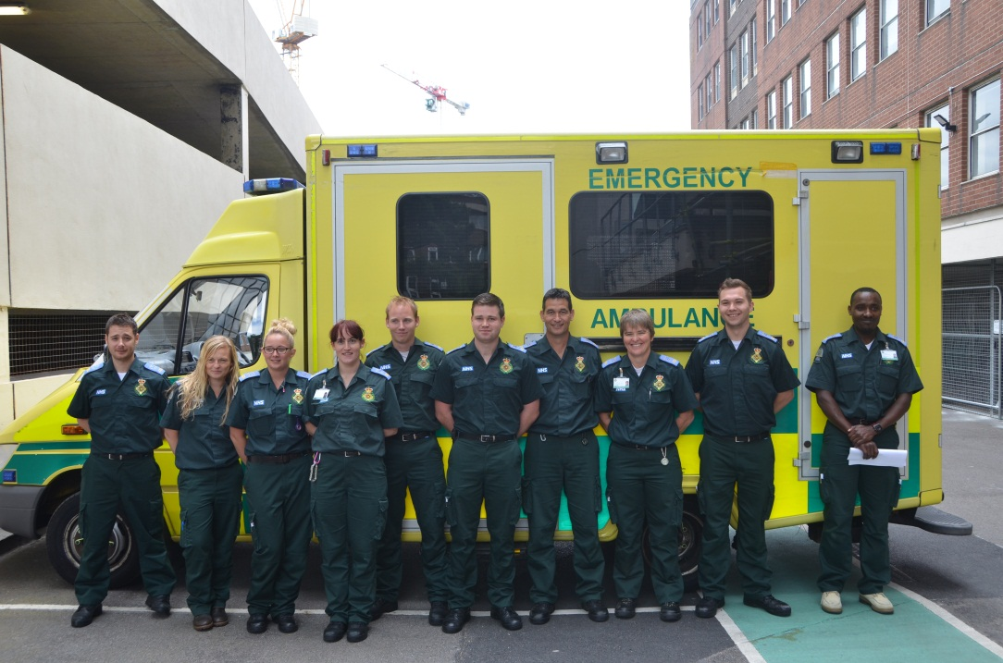
Image: Paramedic science students with their training ambulance donated by the South West Ambulance Service NHS Trust

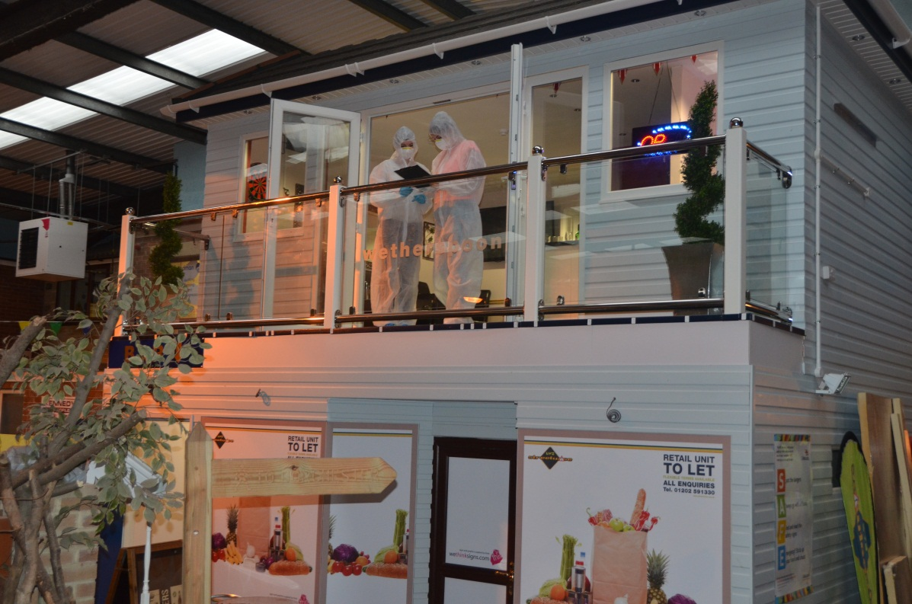
Image: BSc Forensic Science students at Streetwise investigating a mock murder scene scenario

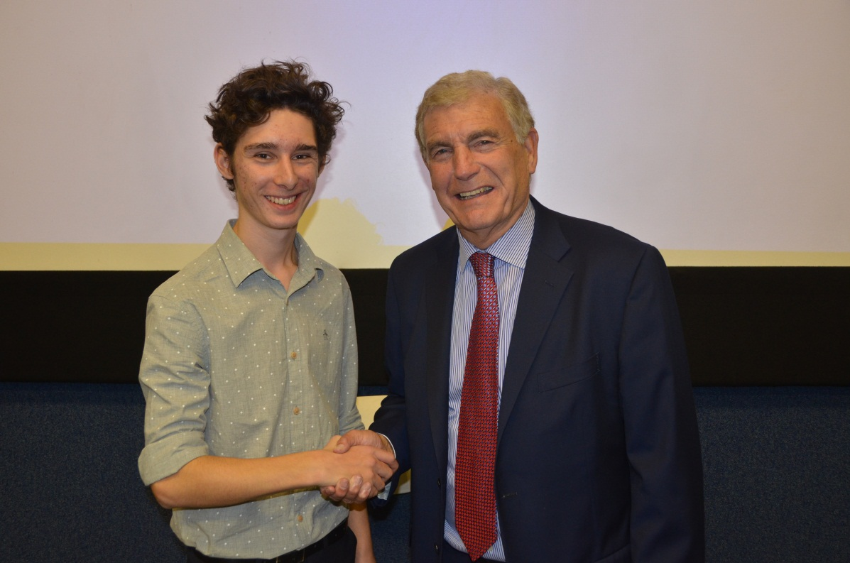
Image: Faculty of Management first year students Grant Hilbourne invited former footballer and broadcaster Sir Trevor Brooking to give a lecture to his course mates

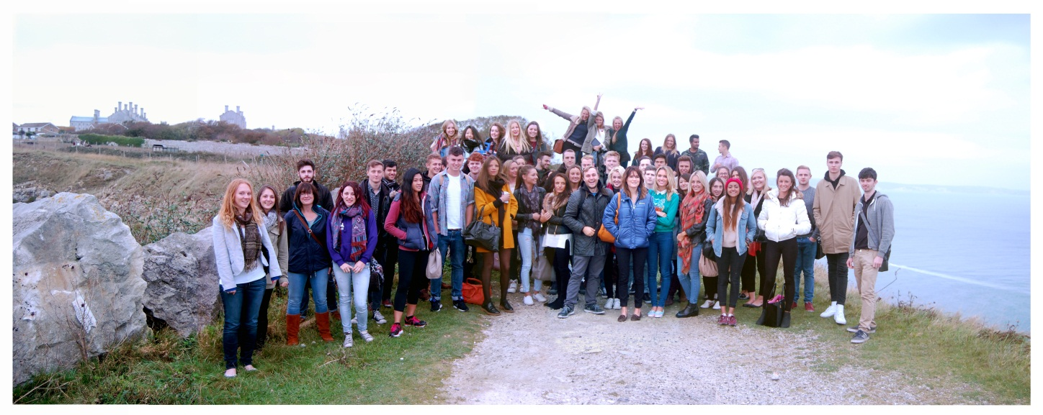
Image: Creativity in Communications students at the site of Jurassica of Portland, for whom they’re developing a communications plan
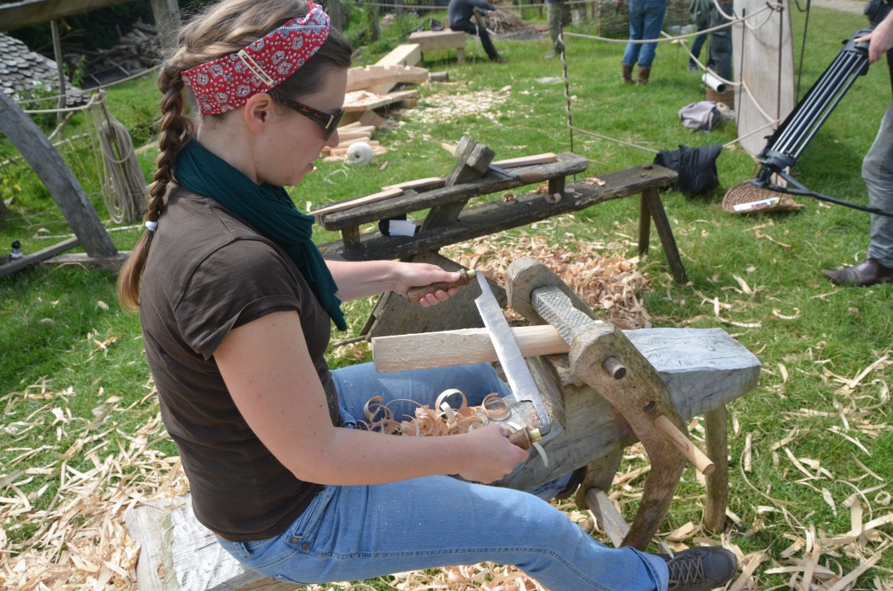
Image: Staff and students involved in ShipWrEx: an experimental archaeology project reconstructing a ship’s hull using ancient techniques

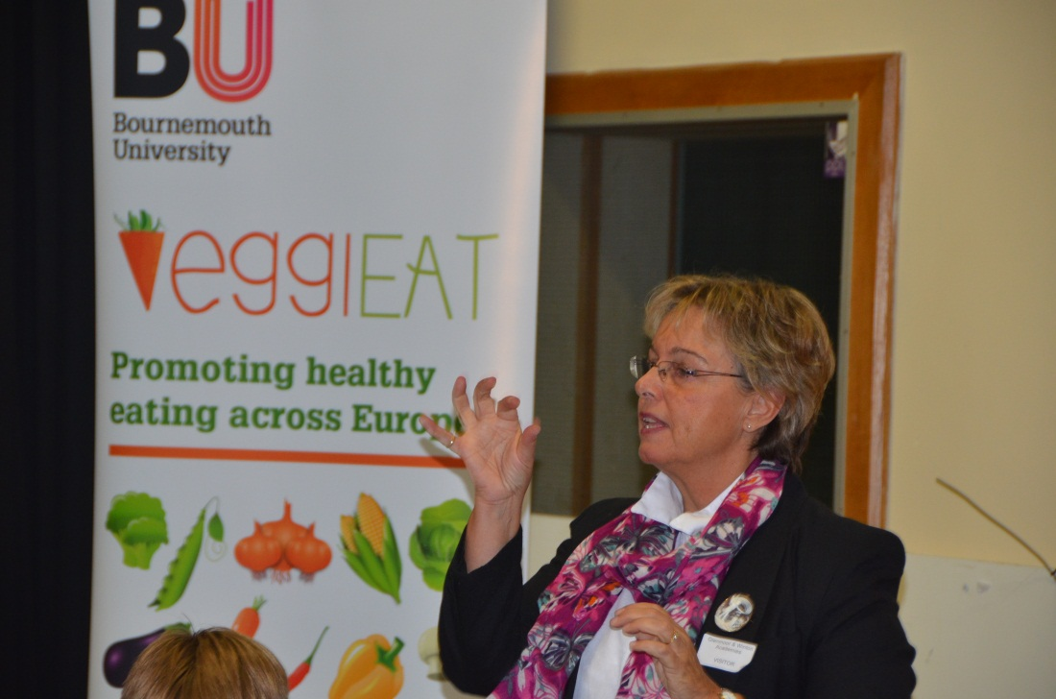
Image: Dr Heather Hartwell conducting taste testing with Winton school children for her EU-funded project, VeggiEAT. This event was part of the ESRC Festival of Social Science

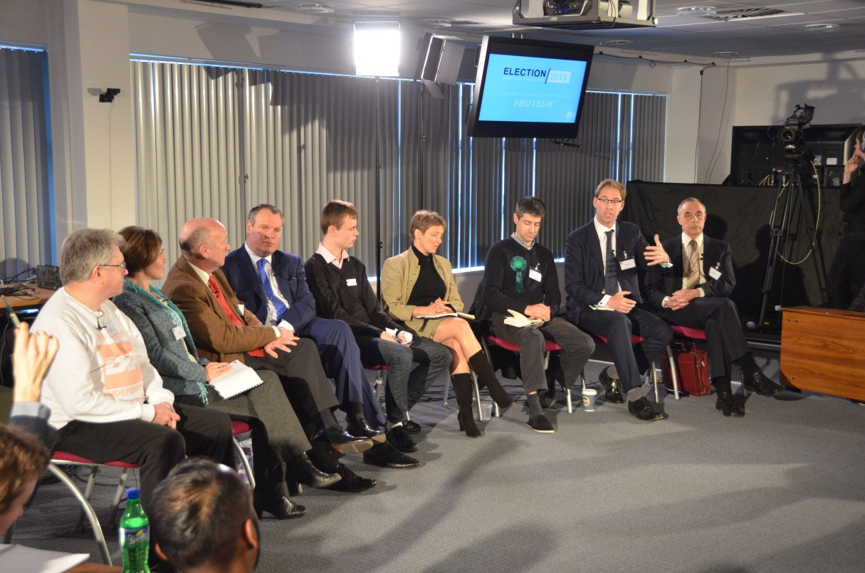
Image: MPs and polititions – including Conor Burns MP, Tobias Ellwood MP and Clare Moody MEP – attended an event about youth voter engagement. It was run by BA Politics and Media students for school children in Bournemouth and Poole

[Sub-heading] Twitter Feed
@sportBU #WinterWednesday!
We are hoping for some brrrr-illiant results from today from our Varsity Teams. #BUProud #BringHomeTheW

Chloe S-Wilson @SubuPresident
After Xmas, the @bournemouthuni tree will go back into a Biomass boiler to power Poole House #BUProud @SUBUGreen

Christie Collins @Christie_2489
Uni has changed my life & I wouldn’t have it any other way #nevertolatetolearn #PRstudent

Bournemouth Uni @bournemouthuni
#AlmostMarried, a film by BU alumni Ben Cookson, has been nominated for best comedy @theFilmAwards

Andie Davies @andiejae
Three years ago today I had my @ bournemouthuni interview! Its gone by so fast! #bestuniever

Jessica Gibson @Jessicagibson93
Looking over bmouth photos & there’s so many memories, from flat 48 cbourne, 66 shelly and 144 hank! Highs outweigh any lows! #BUProud

Bournemouth Uni @bournemouthuni
BU welcomed @nick_clegg today as he announced the expansion of @DorsetLEP #GrowthDeal

Bournemouth Uni @bournemouthuni
We’ll be watching BU graduate @iamdanduke this Saturday on @BBCTheVoiceUK #BUProud

Daniel Duke @iamdanduke @bournemouthuni @BBCTheVoiceUK
Glad you’ll be tuning in guys! BU gave me a lot of opportunities to chase my dream! Thanks for everything.

Sophia @phosphori
BU has given me unforgettable stories and invaluable connections. Best bit is, even as a 4th year, it’s not over yet! #BUProud #BUcommunity

Jane @JaneKetley
Today @BUFalcons raised £732.82 bag packing at Asda, amazing work team #bufalcons #BUProud

Bournemouth Uni @bournemouthuni
BU won ‘Best Research Website @edustyle Awards in both the People’s Choice & Judge Award #BUProud

[Heading Thirteen] Dates for your diary

[Sub-heading] SUBU Full Time Officer Elections
Monday 2 – Friday 27 February
Vote for your new full-time officers in the Students’ Union

[Sub-heading] Eating Disorder Week
Monday 23 – Friday 27 February
A number of events will take place to support Eating Disorder Week

[Sub-heading] Mike Warne Lecture
Wednesday 25 February, 6pm-9pm, Kimmeridge House
An annual event organised by BA Hons Marketing students, showcasing best practice in marketing and communications Visit Eventbrite to register

[Sub-heading] Get that job
Wednesday 25 February, Poole House
An employer-led event for students, who will be given advice on how to become more employable Visit bucareers.wordpress.com for more information
[Sub-heading] SURE Conference
Wednesday 4 March An opportunity for students to showcase their work to the wider academic community and external organisations

[Sub-heading] Momentum Cycle Challenge
Monday 9 – Sunday 29 March A competition where BU competes against other businesses to see which workplace can get the most staff to try cycling Visit www.lovetoride.net.

[Sub-heading] Easter Bank Holiday
Friday 3 – Monday 6 April inclusive

[Sub-heading] UCAS Convention
Wednesday 15 April, Kimmeridge House
The Higher Education fair helps students plan their future options. Register at www.ucas.com/ news-events/events

[Sub-heading] Service Excellence Conference
Wednesday 22 April, Kimmeridge House
A one day conference on Service Excellence for all staff across BU. Sign up on the Staff Intranet

[Sub-heading] Student Development Awards
Wednesday 6 May, 6pm, Kimmeridge House
This ceremony celebrates the hard work and commitment given to extra-curricular activities, alongside regular studies, by those students who have achieved the SDA award

[Sub-heading] Fairtrade Fortnight
Monday 23 February – Sunday 8 March Numerous events will be held across BU in support of Fairtrade

[Sub-heading] Creative Tuesdays
Every Tuesday in the Atrium Art Gallery Balcony Lounge
A weekly drop-in between noon and 2pm for anybody who would like to knit, sew or make/create drawings, arts and crafts

[Sub-heading] Café Scientifique
First Tuesday of every month
Explore the latest ideas in science and technology at Café Boscanova, 650 Christchurch Road, Boscombe http://cafescibournemouth.wordpress.com

[Sub-heading] For more information about events at BU, please visit news.bournemouth.ac.uk/events or contact the Events Team on 01202 961018/buevents@ bournemouth.ac.uk.

